Sreeramamurthy Tripuramallu
903057502

ECE 3056 Homework02 Report

The essence of my program is to develop an energy model to compute the dynamic power dissipation and the reconstruction error (%) when filtering images. The reconstruction error is defined by:

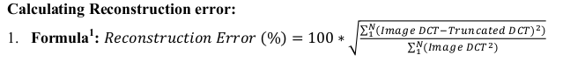
Thus, there are two main counters in the algorithm; the first is the numerator and the second is the denominator. As the program iterates through the image array it identifies values that are outside of the bounds (where the bound is defined by ARRAY_WIDTH – dctTERMS). These values of the image array are added to the numerator, and are replaced with zeros in output file. Moreover, all values of the image array are added to the denominator. Once, the program completes the iteration process through the image, the reconstruction error is calculated by taking the square root of the numerator/denominator and multiplied by 100. Also, the energy is calculated by cubing the ARRAY_WIDTH – dctTerms value. This value is cubed, because an NxN matrix multiplied by an NxN matrix, results in N^3 multiplications. The ARRAY_WIDTH value is not cubed, because it is pointless to consider 0*0 as a multiplication (the 0's being the values of the image that are outside of the ARRAY_WIDTH bound). Once the energy is determined, the power is calculated by multiplying by 30, since it is assumed that it
takes 1/30th of a second for an image to be processed. Lastly, the program prints the reconstruction error and the power consumption.

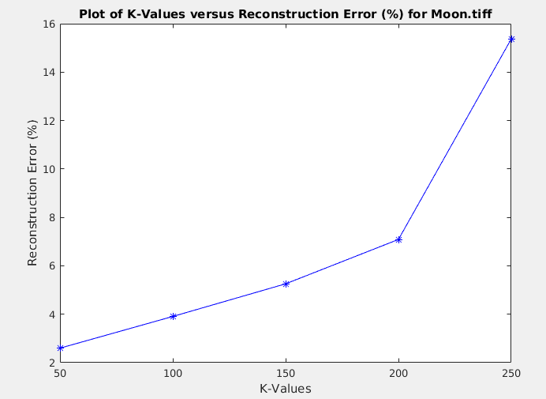

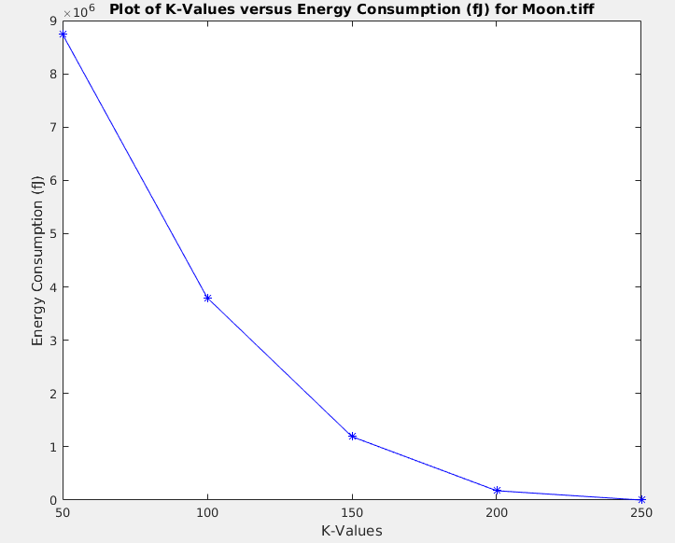
As the K-values increase the reconstruction error increases; this is because as K increases there are more DCT coefficients that turn to zero, thus resulting greater error in the image reconstruction. Also, as the K-values increase the energy consumption decreases, because the increase in K-values means that there are a greater number of 0*0 multiplications, which can be ignored; hence the energy diminishes.

